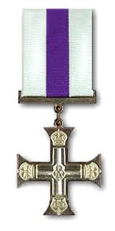
Harold Thompson Valentine

Harold Thompson Valentine was awarded the Military Cross in 1916.
He was a Temporary Captain serving in the South Lancashire Regiment (aged 27).
Details of the award were published in the London Gazette on 14th November 1916:

2nd Lt. (temp. Capt.) Harold Thompson Valentine, S. Lan. R.
For conspicuous gallantry in action. '' He dug advanced trenches under
very heavy fire with great courage and determination.
He set a splendid example to his men.
It is not known where the incident took place but it is believed that he was serving on the Western Front at the time. Possibly took place around Guillemont in early August (but this is only speculation).
--------------------------------------------------------------------------------------------------------------------------
The Military Cross (MC) is the third-level military decoration awarded to officers.
The MC is granted in recognition of "an act or acts of exemplary gallantry during active operations against the enemy on land to all members, of any rank”.
The award was created in 1914 for commissioned officers of the substantive rank of Captain or below and for Warrant Officers.
Recipients are entitled to the postnominal letters MC. (Information from Wikipedia)
--------------------------------------------------------------------------------------------------------------------------
London Gazette, second supplement 14th November 1916.
Pages 11039, 11044 & 11069
1) Page 11039 is front page with publishing date etc...
2) Page 11044 shows start of list of Military Cross awards
3) Page 11069 shows entry above re Harold Thompson Valentine.
Citations in the London Gazette are typically some 3 months after the date of the action for which they were awarded, though this could be a longer period at times of great actions, such as the Somme battles.
--------------------------------------------------------------------------------------------------------------------------
Mark Barnes – July 2012

